Debangana Chatterjee

Superstore Sales Performance-Project

Developed an interactive sales performance dashboard using Tableau to analyse Superstore’s key business metrics across regions, product categories, and customer segments and using data visualizations to track KPIs such as total sales, profit, order quantity and sales per customer, enabling insights into trends and patterns over time, performing month-based analysis to identify underperforming areas and growth opportunities. Implemented advanced features like filters, calculated fields to improve the dashboard’s usability and provide actionable insights.

**The different types of views are as follows:**

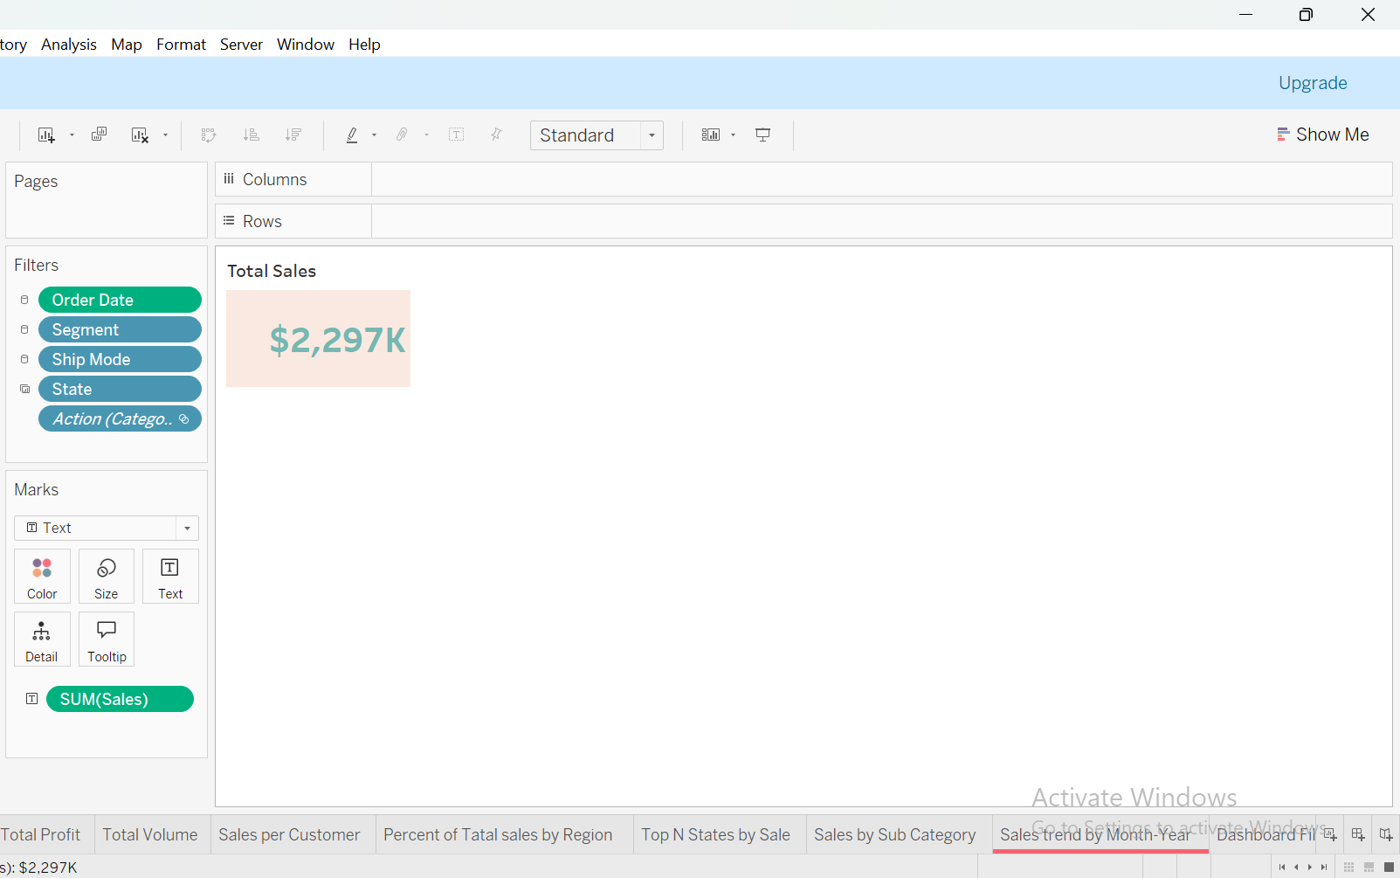

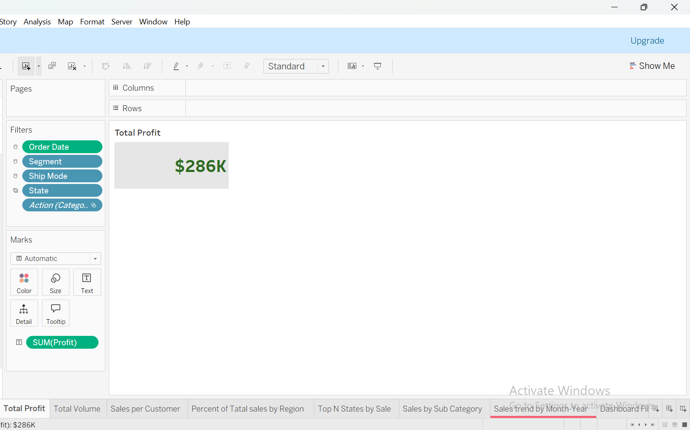

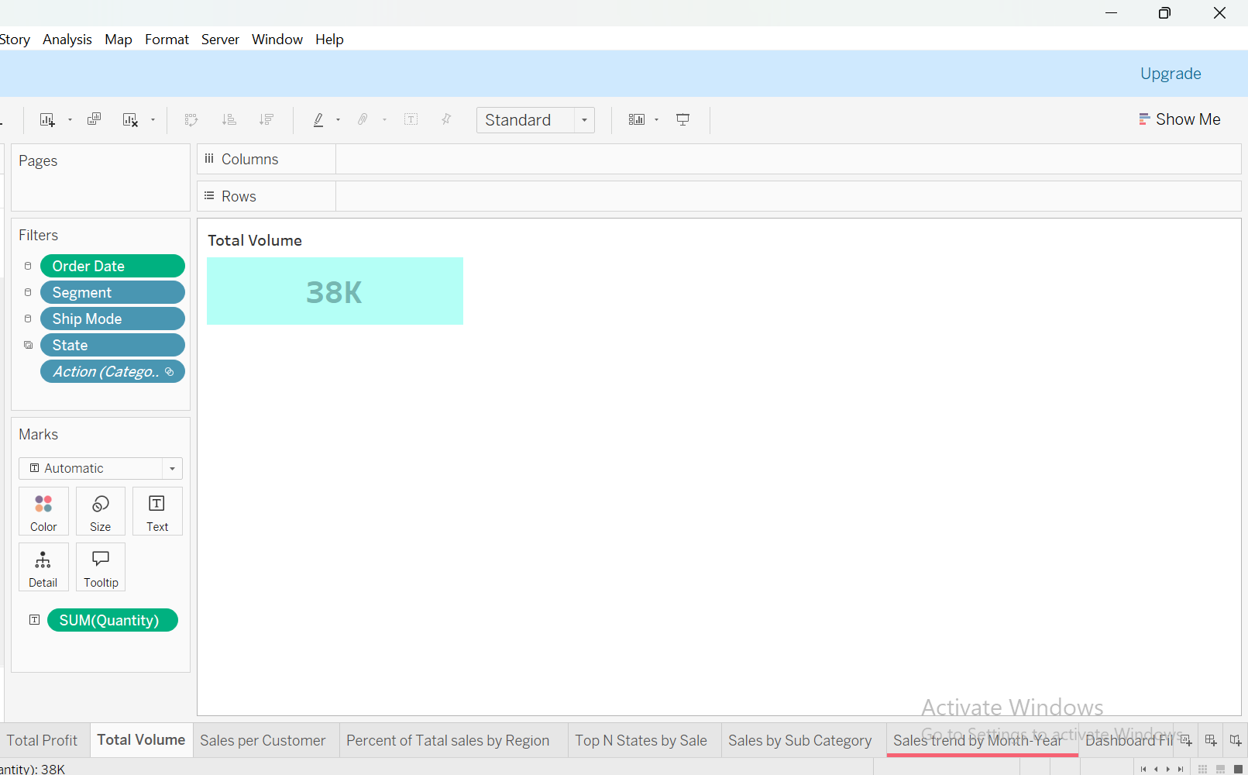

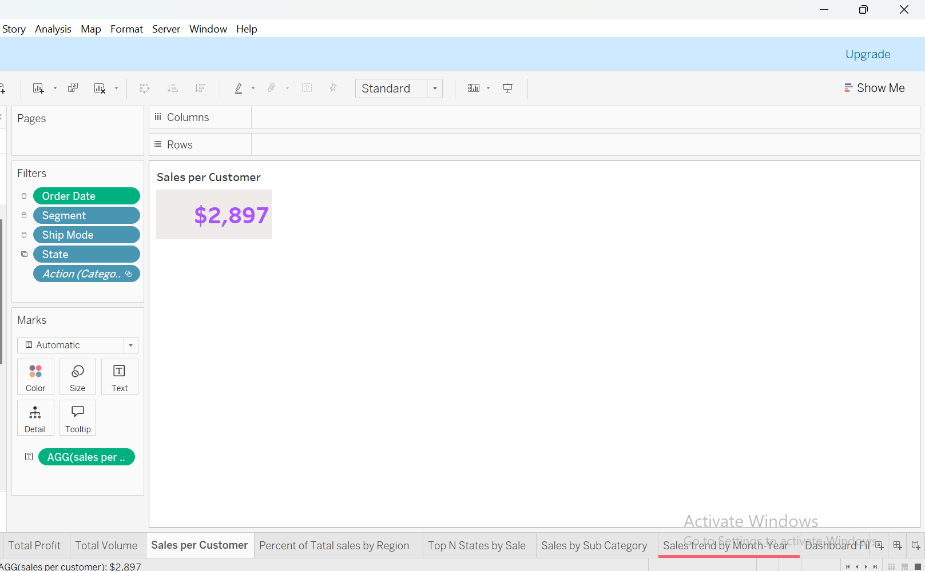

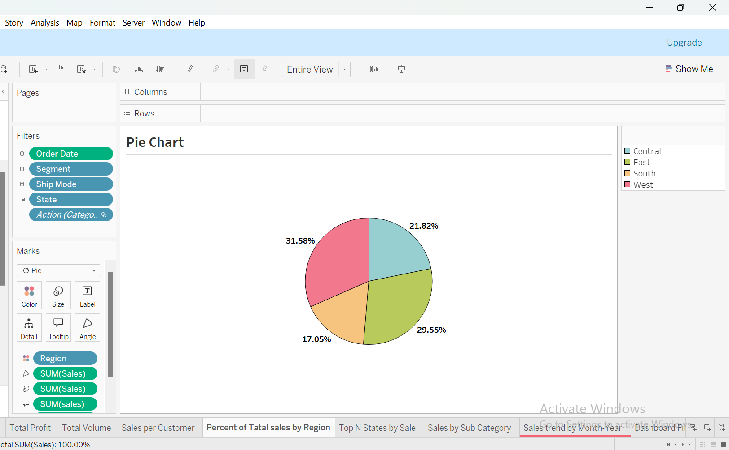

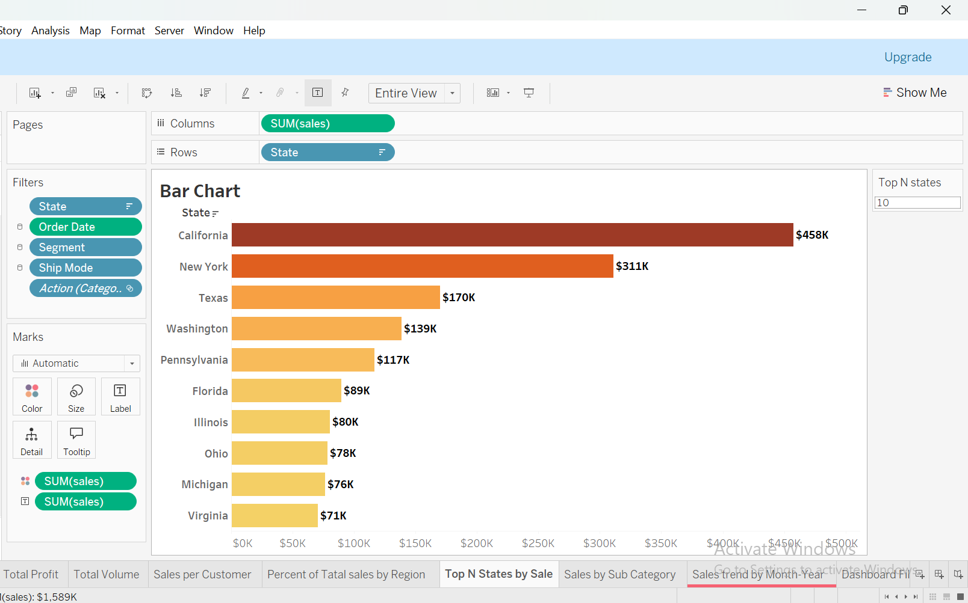

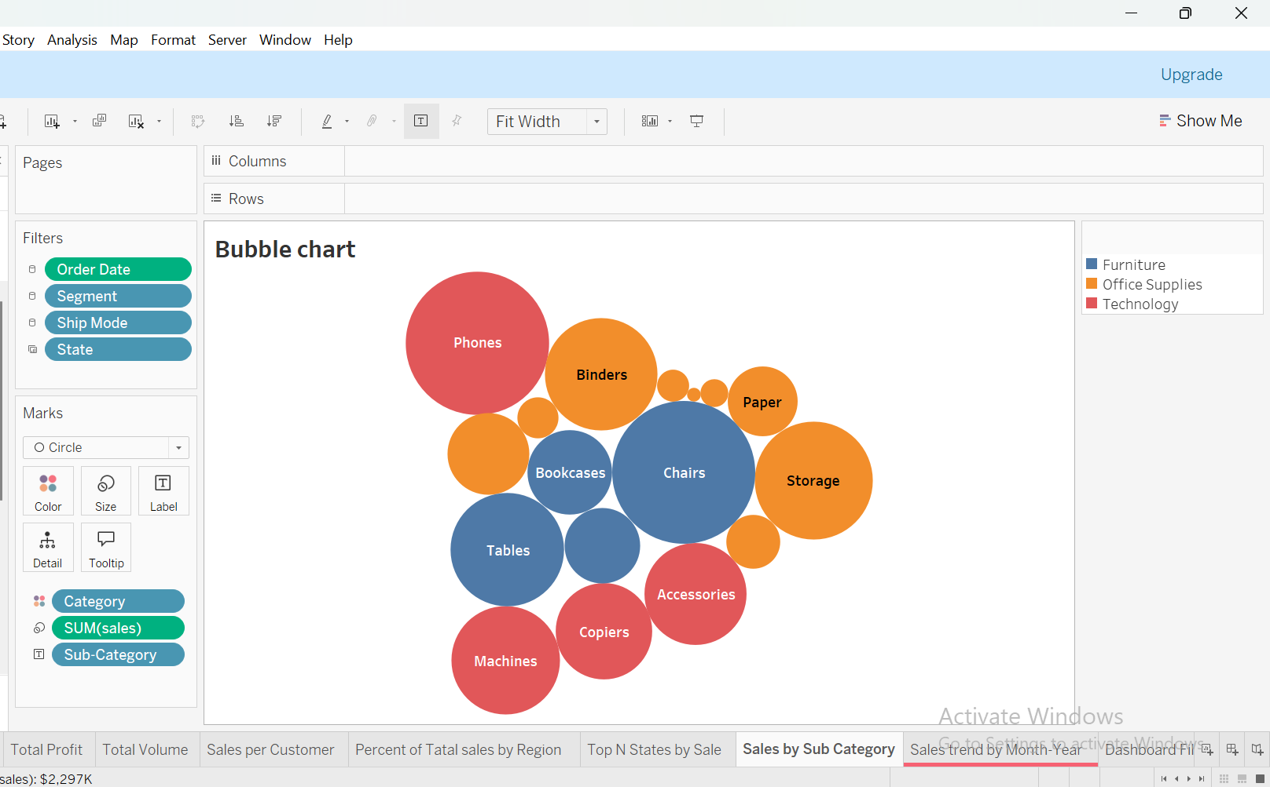

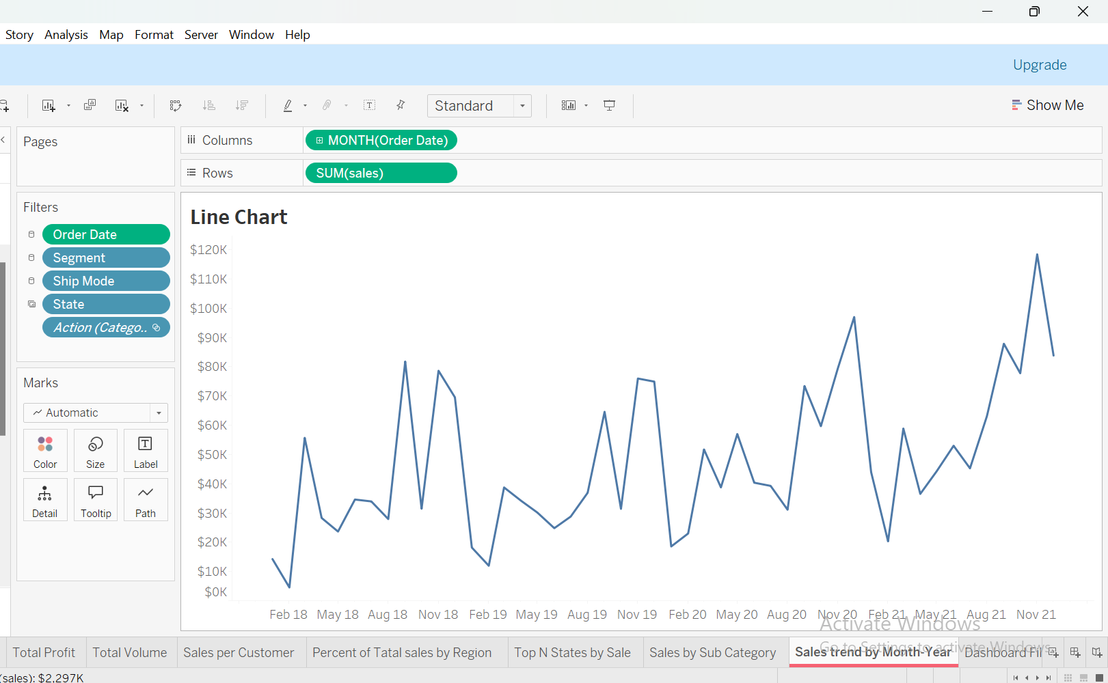

**The Dashboard:**

Created a comprehensive single-Dashboard to visualize sales data, implemented advanced features like filters, calculated fields to improve the dashboard’s usability and provide actionable insights.

